
Kumar Boste
https://github.com/KumarBoste/Student_Performance_and_Attendance_System

Index
- Project Overview
- Problem Statement
- Database Schema & Tools
- Entity Relationship Diagram (ER Diagram)
- Analysis 1 – Basic Queries
- 1. List all students.
- 2. Show all subjects and their teachers.
- 3. Display student attendance details.
- 4. Find students in class ‘10A’.
- 5. Show all students who scored more than 80 marks.

- Analysis 2 – Advance Queries
- 6. Average marks of each subject.
- 7. Correlation between attendance and performance.
- 8. Identify students with attendance below 70%
- 9. Rank students by total marks.
- 10. Average attendance per class.
- SWOT Analysis
- Conclusion

1. Project Overview
The Student Performance & Attendance System is designed to track students’ academic results and attendance details to evaluate their overall performance. This system helps educational institutions analyze how attendance impacts academic outcomes and identify students who need support.

2. Problem Statement
Educational institutions often face challenges in evaluating the link between student attendance and academic performance. Manual tracking makes it difficult to:
- Identify students with low attendance or grades.
- Analyze subject-wise performance trends.
- Support teachers with actionable insights.
This system aims to solve these issues by maintaining a structured database in PostgreSQL that connects students, subjects, attendance, and marks.

3. Database Schema & Tools

Database : PostgreSQL
Tool : PgAdmin 4

Overview of the Schema :
The Schema consists of 4 interconnected tables that provide insights into the “Student Performance & Attendance System”.

The project involves multiple table :
- Students
- Subjects
- Attendance
- Marks

4. Entity Relationship Diagram
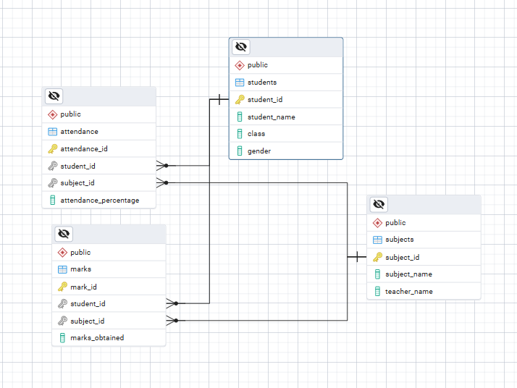

5. Analysis 1 – Basic Queries
1. List all Students
Question:
Show all details of students in the database.

SQL Query :
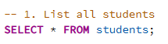
Output :
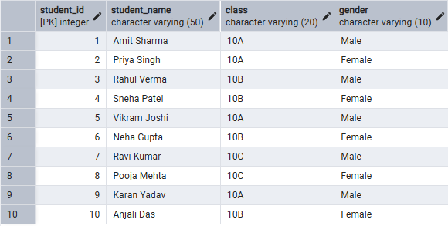

Insight:
Displays all student details — used for verification and roster generation.
2. Show all Subjects and their Teachers
Question:
Which subjects are taught, and who teaches them?

SQL Query :
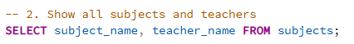

Output :
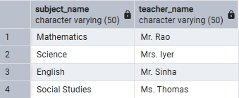

Insight :
Helps identify which teacher teaches which subject.

3. Display Student Attendance details

Question:
Show each student’s attendance percentage per subject.

SQL Query :
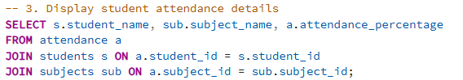

Output :
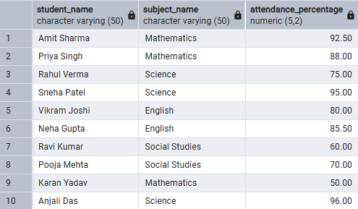

Insight :
Gives attendance data for each student per subject.
4. Find Students in Class ‘10A’

Question:
List the names of all students belonging to class 10A.

SQL Query :
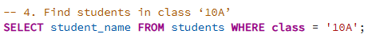

Output :
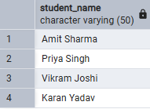

Insight :
Helps teachers or class monitors view class-wise lists.
5. Show all Students who scored more than 80 marks

Question:
Which students scored above 80 in any subject?

SQL Query :
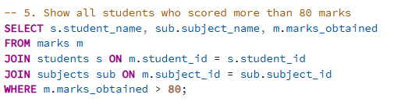

Output :
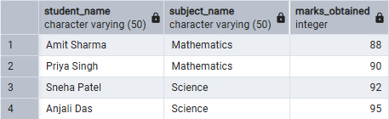

Insight :
Identifies top performers in each subject.

6. Analysis 2 – Advance Queries
6. Average Marks of each Subject
Question:
What is the average score per subject across all students?

SQL Query :
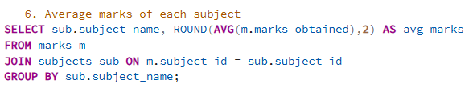

Output :
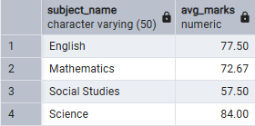

Insight :
Helps evaluate subject difficulty and teaching effectiveness.

7. Correlation between Attendance and Performance
Question:
Is there a link between attendance percentage and marks obtained?
SQL Query :
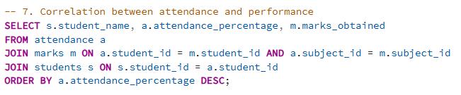
Output :
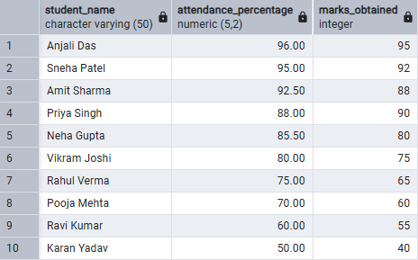
Insight :
Observe if students with higher attendance generally have higher marks.
8. Identify Students with Attendance below 70%
Question:
Which students have poor attendance (less than 70%)?

SQL Query :
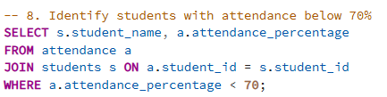

Output :
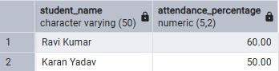

Insight :
Helps teachers identify students at risk due to low attendance, allowing intervention before exams or poor performance.
9. Rank students by total marks
Question:
Rank students based on their overall total marks.
SQL Query :
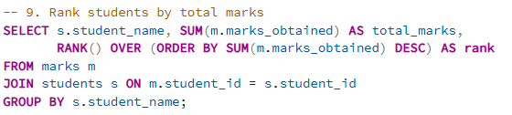Output :
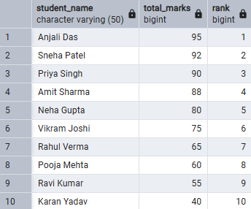
Insight :
Provides a leaderboard that useful for progress reports, merit lists, or end-term analysis.
10. Average attendance per class
Question:
Which class maintains better average attendance overall?

SQL Query :
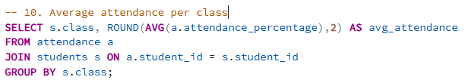
Output :
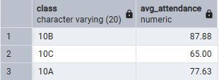

Insight :
Determines which class maintains better attendance discipline.

7. SWOT Analysis

Factors | Description
Strengths
  Efficient tracking of attendance and performance, easily scalable, supports detailed insights.
Weaknesses
  Depends on data accuracy; manual data entry can introduce errors.
Opportunities
  Integration with dashboards, machine learning for predicting performance trends.
Threats
  Data privacy and security if student data is mishandled

8. Conclusion

